Team 2 – New Retail Store Creation and Maintenance

Project Proposal and Plan

# Introduction

Scalability and profitability are the two factors that determine the growth of any business. In retail industry, it is very common that new store gets established very often. This immediately creates the need for the new store to have the necessary software to manage its day to day tasks.

It is a hectic task to create a new web application and provide separate access to each new sub branch that is set up that includes maintenance of its data to track the business related operations.

To overcome this problem, we have come up with a solution that gave us base for developing our project “New Retail Store Creation and Maintenance”. Our main objective behind developing this project is to avoid the redundancy and re-organization of the existing data whenever a new store is created from the existing parent store.

## Project Overview and Statement of Proposal

Our project "New Retail Store Creation and Maintenance" aims to quickly provide software services required to run a new store.

**Statement of Proposal:**

We propose to automate the task of providing a web application service to the newly created store from an existing parent store with just a single click by the new Store Head. When an existing parent store establishes a new sub store irrespective of the location, the system would enable the client to provide all the required services corresponding to the new store. This is an automated process, in which client configures required data and the store is created automatically.

The application allows creation of new store and defines the departments present in the store. Inventory of various items sold in the stores is maintained and updated accordingly. Store customer will be issued a store credit card upon request. Points are added to the customer credit card based on the purchases made. The system generates bill for the items that have been sold. The application allows special deals to be configured on items sold in the store.

## Scope and Objectives

The various objectives that are in the scope of the project can be broadly classified as follows:

### Creation of New Stores

The application allows creation of new store, configure the store various departments the store has and assign department heads to each department. The task of creation of a new store is carried out by Store Head.

### Inventory Management

The inventory keeps track of various items that a store sells. Sales, promotions, customer rewards are interlinked with the inventory. Store head can manipulate items of any department. Department head can manipulate items in his/her department. Sales, returns, promotions, customer rewards also trigger changes/ updates to inventory.

### Promotions and Clearances

It is common for stores to provide special discounts on products during sales. The application allows such special discounts to be set up on various items sold by a store. Store head can create promotions and clearances over items of any department. The department head can create promotions and clearances over items of his/her department.

### Customer Points System

The application allows customers with the store credit card eligible to earn points upon purchases. These points are linked with the store credit card. Points need to be added upon purchase and deducted accordingly upon returns. Upon accumulation of certain points, the points can be used to claim an extra discount offered by the store.

### Point of Sales

All the activities that happen at a point of sale need to be tracked. Activities include generation of bills, handling returns, updating inventory accordingly, updating reward points if the customer owns a store credit card.

**Out of Scope:**

1. The application does not support interaction with barcode scanners and card readers required for credit or debit cards while billing items.
2. The application does not provide the required analytics to help decide the special deals and promotions to be put on items
3. The application does not support multiple currencies or any kind of international transactions. All transactions are in US Dollars.
4. Departments that a new store can have must be selected from a set pre defined values by the parent store
5. The application is limited in handling store credit cards. The application does not validate whether or not a customer is eligible to be granted a store credit card. Everyone who applies for a store credit card gets it.
6. Currently promotions or clearances or any kind discounts offered need to be in the form of percentage discounts. Other kinds of special deals are not supported.

**Future Enhancements:**

1. Adding support for hardware such as card readers and bar code scanners.
2. Adding support for data analytics to help make managerial decisions such as discounts on items and identifying items that need to be put special promotions.
3. Adding support to multiple currency transactions.
4. Expanding the application's support to store credit cards by help deciding the customers eligible for allocating store credit.
5. Adding support to different types of store credit cards like platinum, gold and silver store credit cards based on the frequency and amount of purchases.
6. Adding support to buy one get one offers apart from discounts on price.

# Risk Management Strategy

## Risk Table

|  |  |  |  |  |
| --- | --- | --- | --- | --- |
| Risk ID | Risk Title | Category | Probability | Impact |
| Risk#1 | Using old software or technologies with less support | TE | Low | 2 |
| Risk#2 | Team members can get sick | PE | Moderate | 2 |
| Risk#3 | Using unpopular development tools | TR | Low | 2 |
| Risk#4 | Failing to estimate time for tasks correctly results in delays in submitting deliverables | ES | Moderate | 2 |
| Risk#5 | Missing requirements, inconsistency among requirements | RE | Moderate | 3 |
| Risk#6 | Team member’s unfamiliarity with technologies used in developing the software | PE | Moderate | 3 |

**Category values: Impact values:**

TE – Technology Risk 1 – catastrophic

PE – People Risk 2 – critical

OR – Organizational Risk 3 – marginal

TR – Tool Risk 4 – negligible

RE – Requirements Risk

ES – Estimation Risk

## Discussion of Risks to Be Managed

Discuss the contents of the risk table. Indicate why project includes or does not include certain risks. Explain the severity and probability of the risks.

**Risk#1:** Using old software or technologies with less support

Using older technologies lead to lack of support for the software when some trouble occurs. Using technologies that are likely to be discontinued also have the same risk. This risk is less likely to occur as the technologies that we have chosen for development are Java 7, MySQL 5.6 which are relatively new with ample support available online.

**Risk#2:** Team members can get sick

3 out of the 5 member development team are new to the location of work. There is a moderate chance that team members get sick in such new location, which in turn results in delayed completion of the sick individual’s tasks. The impact will be marginal as it can be covered by other team members

**Risk#3:** Using unpopular development tools

Using unpopular development tools can lead to frustration as there might not be enough support available online to help rectify issues. There is a low probability that this will happen as we are using Eclipse IDE, Microsoft Word, Visio and Project which are popular choices. The impact due to this risk is marginal

**Risk#4:**Failing to estimate time for tasks correctly results in delays in submitting deliverables

Inexperience of the development team can lead to incorrect time estimates for various tasks of the project. This can lead to delayed submissions. There is a moderate probability that this will occur and the impact will be marginal.

**Risk#5:**Missing requirements, inconsistency among requirements

Unfamiliarity with the domain of the retail stores can cause development team to misunderstand or miss certain requirements. The probability of occurrence of this risk is marginal and the impact will be critical especially as we proceed further into the project

**Risk#6:**Team member’s unfamiliarity with technologies used in developing the software

Team member’s unfamiliarity with technologies used in developing the software i.e. Java and MySQL can result in more time to implement the project. The probability of this risk is moderate and impact will be critical

## Risk Mitigation, Monitoring, and Management Plan

This section describes what is to be done to avoid each risk (mitigation), how the team will monitor its activities to detect when a risk becomes a problem (monitoring), and what will be done for each risk if it becomes a problem (management – i.e., contingency plans). Keep in mind that some activities may help to mitigate/monitor more than one risk while some risks may require multiple mitigation/monitoring activities. Furthermore, the same contingency plan may apply to more than one risk.

**Risk#1:**Using old software or technologies with less support

This risk can be mitigated by choosing latest versions of the software. We have chosen Java 7 and MySQL 5.6 which are relatively newer versions of the software. We did not choose Java 8 as it is too new and we did not want to use something that hasn’t been yet tried a lot.

**Risk#2:**Team members can get sick

This risk has to monitored for and managed by rescheduling or reassigning task assigned to the sick team member

**Risk#3:**Using unpopular development tools

This risk can be mitigated by choosing open source software or freeware unless needed otherwise. The software we have chosen is Java 7 which is freeware, MySQL 5.6 Community edition which is also open source and freeware. Microsoft Word, Visio and Project though not freeware are available free of cost as all development team members are students at UNCC

**Risk#4:** Failing to estimate time for tasks correctly results in delays in submitting deliverables.

This risk can be managed by keeping a buffer i.e. allocating the tasks slightly more time than the estimate made to complete the tasks. If the risk still becomes a problem then the tasks have to rescheduled along with the next set of deliverables

**Risk#5:** Missing requirements, inconsistency among requirements

This risk has to be continuously monitored and managed to detect inconsistencies in requirements. Each time an inconsistency is detected necessary changes must be taken in the design before the inconsistency propagates further.

**Risk#6:** Team member’s unfamiliarity with technologies used in developing the software

This risk has to be monitored and managed

This risk can be monitored by knowing ahead which technologies the team members are familiar and plan to work towards their weaknesses. Team members can share their knowledge in their specialty domain to help others learn.

# Plan

## Timeline Chart

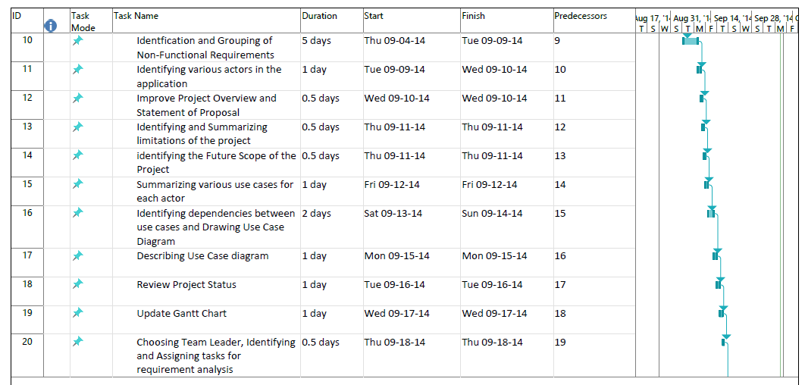

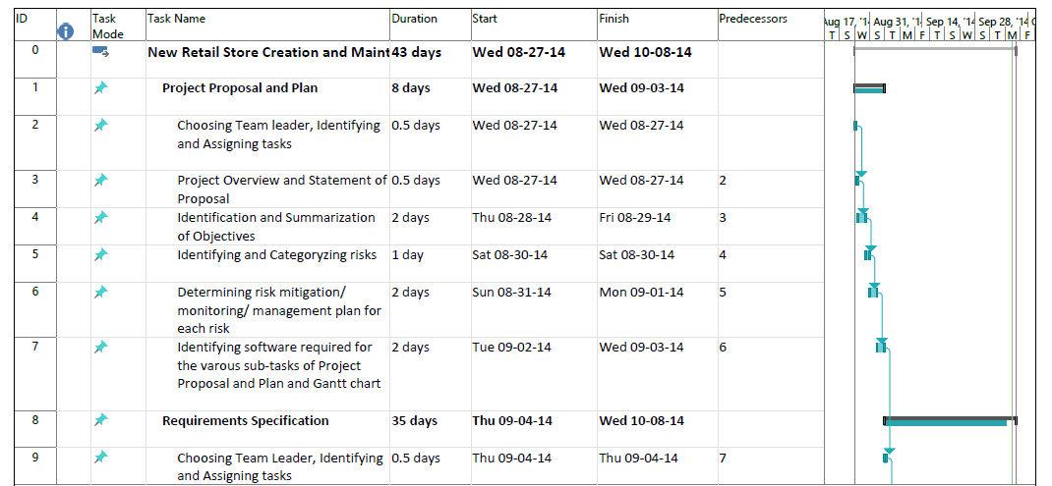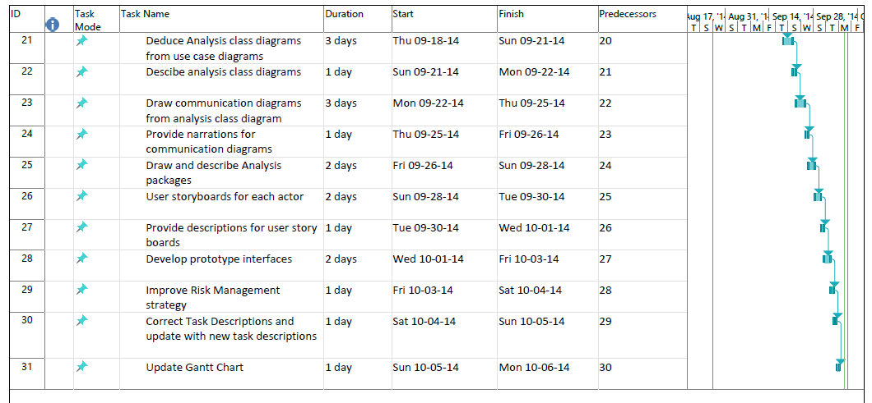

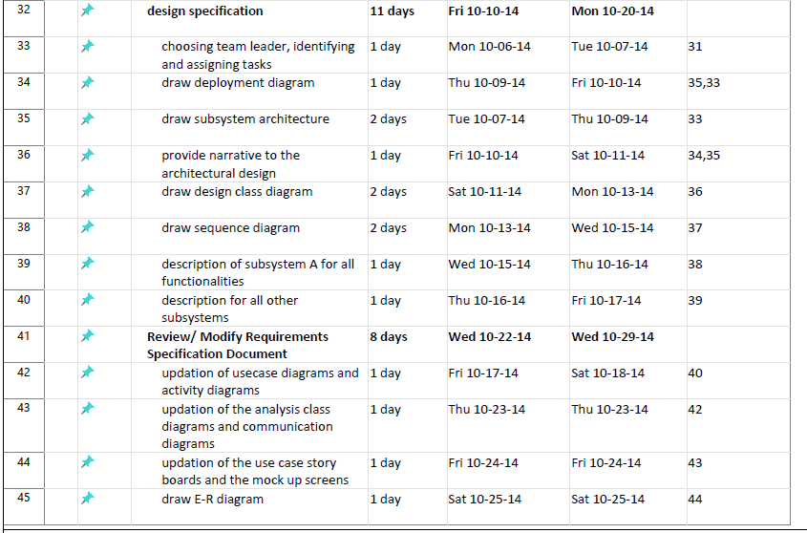

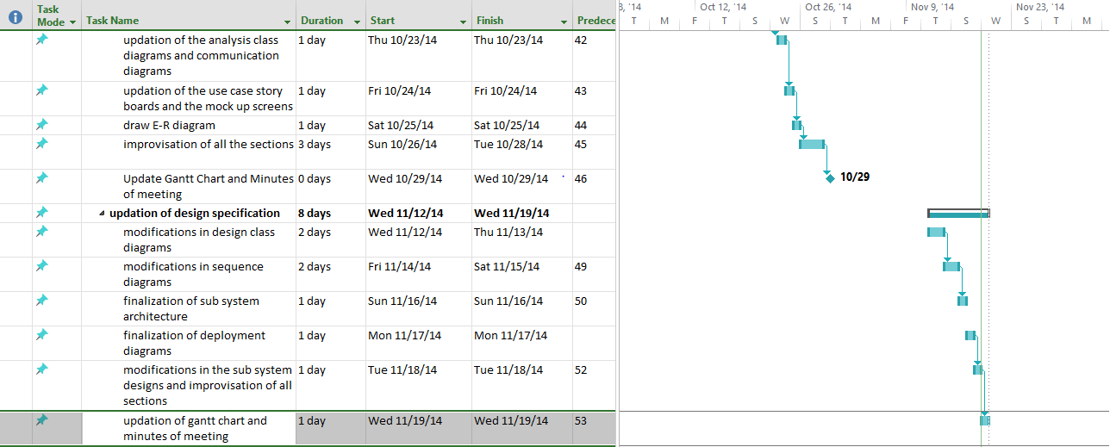

## Task Descriptions

* + 1. Choosing Team leader, identifying and Assigning tasks for Project proposal and plan Requirement specification development: Non-functional and functional requirements are identified. Naga Bijesh Roy Raya is the team leader for this deliverable
    2. Project overview and Statement of proposal
    3. Identification and summarization of Objectives
    4. Identifying and categorizing risks
    5. Determining risk mitigation/ monitoring/ management plan for each risk
    6. Identifying software required for sub-tasks of project proposal and plan, Gantt chart
    7. Choosing Team leader, identifying and Assigning tasks for Project Requirement specification part-1. Rajiv Musunuru is chosen as team leader for this deliverable
    8. Identification and grouping of non-functional requirements
    9. Identifying various actors in the application
    10. Improve Project overview and statement of proposal
    11. Identifying and summarizing the limitations of the project
    12. Identifying the future Scope of the project
    13. Summarizing various use cases for each actor
    14. Identifying dependencies between use cases and Drawing use case diagram
    15. Describing Use case diagram
    16. Update Gantt chart
    17. Review project status

### draw subsystem architecture

### provide narrative to the architectural design

### draw design class diagram

### draw sequence diagram

### description of subsystem A for all functionalities

### description for all other subsystems

### updation of usecase diagrams and activity diagrams

### updation of the analysis class diagrams and communication diagrams

### updation of the use case story boards and the mock up screens

### draw E-R diagram

### improvisation of all the sections

### Update Gantt Chart and Minutes of meeting

### modifications in design class diagrams

### modifications in sequence diagrams

### finalization of sub system architecture

### finalization of deployment diagram

### modifications in the sub system designs and improvisation of all sections

### update gantt chart and minutes of meeting

# choosing team leader, identifying and assigning tasks

## Resource Table

|  |  |  |  |
| --- | --- | --- | --- |
| Task | People | Hardware & Software | Special |
| Choosing Team leader, identifying and Assigning tasks for Project proposal and plan | Naga Bijesh Roy Raya, Lavanya Loganarayanan, Bindhu Komalla, Rajiv Musunuru, Singa Raju Nadimpalli |  |  |
| Project overview and Statement of proposal | Naga Bijesh Roy Raya, Lavanya Loganarayanan, Bindhu Komalla, Rajiv Musunuru, Singa Raju Nadimpalli | MS word |  |
| Identification and summarization of Objectives | Naga Bijesh Roy Raya, Lavanya Loganarayanan, Bindhu Komalla, Rajiv Musunuru, Singa Raju Nadimpalli | MS word |  |
| Identifying and categorizing risks | Naga Bijesh Roy Raya, Lavanya Loganarayanan, Bindhu Komalla, Rajiv Musunuru, Singa Raju Nadimpalli | MS word |  |
| Determining risk mitigation/ monitoring/ management plan for each risk | Naga Bijesh Roy Raya, Lavanya Loganarayanan, Bindhu Komalla, Rajiv Musunuru, Singa Raju Nadimpalli | MS word |  |
| Identifying software required for sub-tasks of project proposal and plan, Gantt chart | Naga Bijesh Roy Raya, Lavanya Loganarayanan, Bindhu Komalla, Rajiv Musunuru, Singa Raju Nadimpalli | MS word, MS project |  |
| Choosing Team leader, identifying and Assigning tasks for Project Requirement specification part-1 | Naga Bijesh Roy Raya, Lavanya Loganarayanan, Bindhu Komalla, Rajiv Musunuru, Singa Raju Nadimpalli |  |  |
| Identification and grouping of non-functional requirements | Naga Bijesh Roy Raya, Lavanya Loganarayanan, Bindhu Komalla, Rajiv Musunuru, Singa Raju Nadimpalli | MS word |  |
| Identifying various actors in the application | Naga Bijesh Roy Raya, Lavanya Loganarayanan, Bindhu Komalla, Rajiv Musunuru, Singa Raju Nadimpalli | MS word |  |
| Improve Project overview and statement of proposal | Naga Bijesh Roy Raya, Lavanya Loganarayanan, Bindhu Komalla, Rajiv Musunuru, Singa Raju Nadimpalli | MS word |  |
| Identifying and summarizing the limitations of the project | Naga Bijesh Roy Raya, Lavanya Loganarayanan, Bindhu Komalla, Rajiv Musunuru, Singa Raju Nadimpalli | MS word |  |
| Identifying the future Scope of the project | Naga Bijesh Roy Raya, Lavanya Loganarayanan, Bindhu Komalla, Rajiv Musunuru, Singa Raju Nadimpalli | MS word |  |
| Summarizing various use cases for each actor | Naga Bijesh Roy Raya, Lavanya Loganarayanan, Bindhu Komalla, Rajiv Musunuru, Singa Raju Nadimpalli | MS Visio |  |
| Identifying dependencies between use cases and Drawing use case diagram | Naga Bijesh Roy Raya, Lavanya Loganarayanan, Bindhu Komalla, Rajiv Musunuru, Singa Raju Nadimpalli | MS Word, MS Visio |  |
| Describing Use case diagram | Naga Bijesh Roy Raya, Lavanya Loganarayanan, Bindhu Komalla, Rajiv Musunuru, Singa Raju Nadimpalli | MS Visio |  |
| Update Gantt chart | Naga Bijesh Roy Raya, Lavanya Loganarayanan, Bindhu Komalla, Rajiv Musunuru, Singa Raju Nadimpalli | MS project |  |
| Review project status | Naga Bijesh Roy Raya, Lavanya Loganarayanan, Bindhu Komalla, Rajiv Musunuru, Singa Raju Nadimpalli | MS word, MS Visio, MS project |  |
| Choosing Team Leader, Identifying and Assigning tasks for requirement analysis | Naga Bijesh Roy Raya, Lavanya Loganarayanan, Bindhu Komalla, Rajiv Musunuru, Singa Raju Nadimpalli |  |  |
| Deduce Analysis class diagrams from use case diagrams | Naga Bijesh Roy Raya, Lavanya Loganarayanan, Bindhu Komalla, Rajiv Musunuru, Singa Raju Nadimpalli | MS word, MS Visio |  |
| Descibe analysis class diagrams | Naga Bijesh Roy Raya, Lavanya Loganarayanan, Bindhu Komalla, Rajiv Musunuru, Singa Raju Nadimpalli | MS word, MS Visio |  |
| Draw communication diagrams from analysis class diagram | Naga Bijesh Roy Raya, Lavanya Loganarayanan, Bindhu Komalla, Rajiv Musunuru, Singa Raju Nadimpalli | MS word, MS Visio |  |
| Provide narrations for communication diagrams | Naga Bijesh Roy Raya, Lavanya Loganarayanan, Bindhu Komalla, Rajiv Musunuru, Singa Raju Nadimpalli | MS word, MS Visio |  |
| Draw and describe Analysis packages | Naga Bijesh Roy Raya, Lavanya Loganarayanan, Bindhu Komalla, Rajiv Musunuru, Singa Raju Nadimpalli | MS word, MS Visio |  |
| User storyboards for each actor | Naga Bijesh Roy Raya, Lavanya Loganarayanan, Bindhu Komalla, Rajiv Musunuru, Singa Raju Nadimpalli | MS word, MS Visio |  |
| Provide descriptions for user story boards | Naga Bijesh Roy Raya, Lavanya Loganarayanan, Bindhu Komalla, Rajiv Musunuru, Singa Raju Nadimpalli | MS word, MS Visio |  |
| Develop prototype interfaces | Naga Bijesh Roy Raya, Lavanya Loganarayanan, Bindhu Komalla, Rajiv Musunuru, Singa Raju Nadimpalli | MS word, MS Visio |  |
| Improve Risk Management strategy | Naga Bijesh Roy Raya, Lavanya Loganarayanan, Bindhu Komalla, Rajiv Musunuru, Singa Raju Nadimpalli | MS word, MS Visio |  |
| Correct Task Descriptions and update with new task descriptions | Naga Bijesh Roy Raya, Lavanya Loganarayanan, Bindhu Komalla, Rajiv Musunuru, Singa Raju Nadimpalli | MS word, MS Visio |  |
| Update Gantt Chart | Naga Bijesh Roy Raya, Lavanya Loganarayanan, Bindhu Komalla, Rajiv Musunuru, Singa Raju Nadimpalli | MS word, MS Visio |  |
| choosing team leader, identifying and assigning tasks | Naga Bijesh Roy Raya, Lavanya Loganarayanan, Bindhu Komalla, Rajiv Musunuru, Singa Raju Nadimpalli | MS word, MS Visio |  |
| draw subsystem architecture | Naga Bijesh Roy Raya, Lavanya Loganarayanan, Bindhu Komalla, Rajiv Musunuru, Singa Raju Nadimpalli | MS word, MS Visio |  |
| draw deployment diagram | Naga Bijesh Roy Raya, Lavanya Loganarayanan, Bindhu Komalla, Rajiv Musunuru, Singa Raju Nadimpalli | MS word, MS Visio |  |
| provide narrative to the architectural design | Naga Bijesh Roy Raya, Lavanya Loganarayanan, Bindhu Komalla, Rajiv Musunuru, Singa Raju Nadimpalli | MS word, MS Visio |  |
| draw design class diagram | Naga Bijesh Roy Raya, Lavanya Loganarayanan, Bindhu Komalla, Rajiv Musunuru, Singa Raju Nadimpalli | MS word, MS Visio |  |
| draw sequence diagram | Naga Bijesh Roy Raya, Lavanya Loganarayanan, Bindhu Komalla, Rajiv Musunuru, Singa Raju Nadimpalli | MS word, MS Visio |  |
| description of subsystem A for all functionalities | Naga Bijesh Roy Raya, Lavanya Loganarayanan, Bindhu Komalla, Rajiv Musunuru, Singa Raju Nadimpalli | MS word, MS Visio |  |
| description for all other subsystems | Naga Bijesh Roy Raya, Lavanya Loganarayanan, Bindhu Komalla, Rajiv Musunuru, Singa Raju Nadimpalli | MS word, MS Visio |  |
| updation of usecase diagrams and activity diagrams | Naga Bijesh Roy Raya, Lavanya Loganarayanan, Bindhu Komalla, Rajiv Musunuru, Singa Raju Nadimpalli | MS word, MS Visio |  |
| updation of the analysis class diagrams and communication diagrams | Naga Bijesh Roy Raya, Lavanya Loganarayanan, Bindhu Komalla, Rajiv Musunuru, Singa Raju Nadimpalli | MS word, MS Visio |  |
| updation of the use case story boards and the mock up screens | Naga Bijesh Roy Raya, Lavanya Loganarayanan, Bindhu Komalla, Rajiv Musunuru, Singa Raju Nadimpalli | MS word, MS Visio |  |
| draw E-R diagram | Naga Bijesh Roy Raya, Lavanya Loganarayanan, Bindhu Komalla, Rajiv Musunuru, Singa Raju Nadimpalli | MS word, MS Visio |  |
| improvisation of all the sections | Naga Bijesh Roy Raya, Lavanya Loganarayanan, Bindhu Komalla, Rajiv Musunuru, Singa Raju Nadimpalli | MS word, MS Visio |  |
| Update Gantt Chart and Minutes of meeting | Naga Bijesh Roy Raya, Lavanya Loganarayanan, Bindhu Komalla, Rajiv Musunuru, Singa Raju Nadimpalli | MS project |  |
| modifications in design class diagrams | Naga Bijesh Roy Raya, Lavanya Loganarayanan, Bindhu Komalla, Rajiv Musunuru, Singa Raju Nadimpalli | MS word, MS Visio |  |
| modifications in sequence diagrams | Naga Bijesh Roy Raya, Lavanya Loganarayanan, Bindhu Komalla, Rajiv Musunuru, Singa Raju Nadimpalli | MS word, MS Visio |  |
| finalization of sub system architecture | Naga Bijesh Roy Raya, Lavanya Loganarayanan, Bindhu Komalla, Rajiv Musunuru, Singa Raju Nadimpalli | MS word, MS Visio |  |
| finalization of deployment diagram | Naga Bijesh Roy Raya, Lavanya Loganarayanan, Bindhu Komalla, Rajiv Musunuru, Singa Raju Nadimpalli | MS word, MS Visio |  |
| modifications in the sub system designs and improvisation of all sections | Naga Bijesh Roy Raya, Lavanya Loganarayanan, Bindhu Komalla, Rajiv Musunuru, Singa Raju Nadimpalli | MS word, MS Visio |  |
| updation of gantt chart and minutes of meeting | Naga Bijesh Roy Raya, Lavanya Loganarayanan, Bindhu Komalla, Rajiv Musunuru, Singa Raju Nadimpalli | MS word, MS Visio, MS project |  |

# Project Resources

## People

1. Naga Bijesh Roy Raya
2. Lavanya Loganarayanan
3. Bindhu Komalla
4. Rajiv Musunuru
5. Singa Raju Nadimpalli

## Hardware and Software Resources

MS-Word, MS-Project, MS-Visio

## Special Resources

# Appendices

09-17-2014 - changes made - Added what is out of scope for the project, discussed future enhancements, updated Resource table, Gantt chart moved to separate MS-project file, modified Risk management strategy

10-08-2014 - changes made - updated section 2 - Risk Management Strategy, task descriptions, attached Gantt chart screenshot and resource table

11-19-2014 updated the Gantt chart and the resource table